Module-2 : Data Structures & Algorithms
231fa04091@gmail.com
Exercise-2 : E-commerce Platform Search Function
What is Big O Notation?
Big O notation describes how the execution time of an algorithm grows as the input size (n) increases.
It helps you:
• Compare different algorithms
• Predict performance for large datasets
• Choose efficient solutions
Best, Average, and Worst Cases for Search Operations
Linear Search
• Best Case: O(1) → Item found at the first position
• Average Case: O(n) → Item found somewhere in the middle
• Worst Case: O(n) → Item found at the last position or not found
Binary Search
• Best Case: O(1) → Item found at the middle position
• Average Case: O(log n)
• Worst Case: O(log n)
Binary search works only on sorted data.
Create a class Product with attributes for searching, such as productId, productName, and category.
Product.cs :
public class Product
{
public int ProductId { get; set; }
public string ProductName { get; set; }
public string Category { get; set; }
public Product(int productId, string productName, string category)
{
ProductId = productId;
ProductName = productName;
Category = category;
}
}
Program.cs :
using System;
class Program
{
static void Main()
{
Product[] products =
{
new Product(101, "Laptop", "Electronics"),
new Product(102, "Headphones", "Electronics"),
new Product(103, "Shoes", "Fashion"),
new Product(104, "Watch", "Accessories"),
new Product(105, "Book", "Education")
};
int targetId = 104;
Product linearResult = LinearSearch(products, targetId);
if (linearResult != null)
{
Console.WriteLine("Linear Search Result:");
Console.WriteLine($"{linearResult.ProductId} - {linearResult.ProductName}");
}

Product binaryResult = BinarySearch(products, targetId);
if (binaryResult != null)
{
Console.WriteLine("\nBinary Search Result:");
Console.WriteLine($"{binaryResult.ProductId} - {binaryResult.ProductName}");
}
}
static Product LinearSearch(Product[] products, int targetId)
{
foreach (Product product in products)
{
if (product.ProductId == targetId)
{
return product;
}
}
return null;
}
static Product BinarySearch(Product[] products, int targetId)
{
int left = 0;
int right = products.Length - 1;
while (left <= right)
{
int mid = left + (right - left) / 2;
if (products[mid].ProductId == targetId)
{
return products[mid];
}
if (products[mid].ProductId < targetId)
{
left = mid + 1;
}
else
{
right = mid - 1;
}
}
return null;
}
}

Analyze the Algorithms :
Feature | Linear Search | Binary Search
Data Requirement | Unsorted or sorted | Must be sorted
Best Case | O(1) | O(1)
Average Case | O(n) | O(log n)
Worst Case | O(n) | O(log n)
Suitable for Large Data | No | Yes

Which algorithm is better?
For an e-commerce platform with a large number of products, binary search is more suitable because it searches much faster on sorted data.
Output:
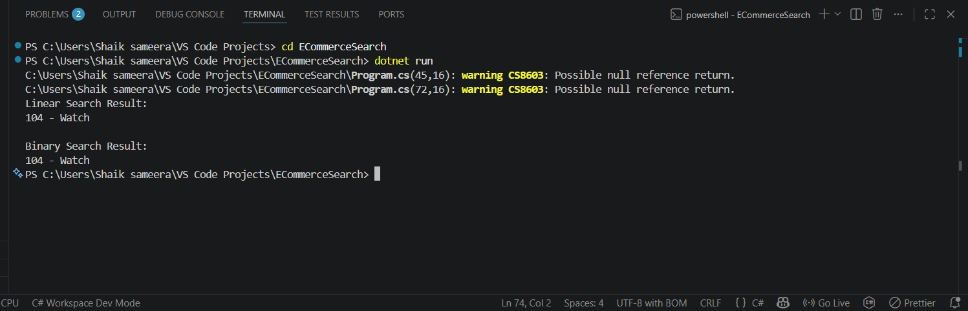

Exercise-7 : Financial Forecasting
What is Recursion?
Recursion is a programming technique in which a method calls itself to solve smaller instances of the same problem.
Every recursive algorithm has two parts:
• Base case: The condition that stops the recursion.
• Recursive case: The part where the method calls itself with a smaller problem.
Use of Recursion :
Recursion can make problems easier to understand and implement, especially when a problem can be broken down into smaller, similar subproblems.
Examples include:
• Factorial calculation
• Fibonacci sequence
• Tree traversal
• Financial forecasting
Create a method to calculate the future value using a recursive approach
Program.cs :
using System;
class Program
{
static double CalculateFutureValue(double currentValue, double growthRate, int years)
{
if (years == 0)
{
return currentValue;
}
return CalculateFutureValue(currentValue, growthRate, years - 1) * (1 + growthRate);
}
static void Main()
{
Console.Write("Enter the initial value: ₹");
double initialValue = Convert.ToDouble(Console.ReadLine());
Console.Write("Enter the annual growth rate (in %): ");
double growthRate = Convert.ToDouble(Console.ReadLine()) / 100;
Console.Write("Enter the number of years: ");
int years = Convert.ToInt32(Console.ReadLine());
double futureValue = CalculateFutureValue(initialValue, growthRate, years);
Console.WriteLine("\n----- Financial Forecast -----");
Console.WriteLine($"Initial Value: ₹{initialValue:F2}");
Console.WriteLine($"Growth Rate: {growthRate * 100:F2}%");
Console.WriteLine($"Years: {years}");
Console.WriteLine($"Predicted Future Value: ₹{futureValue:F2}");
}
}

Output:
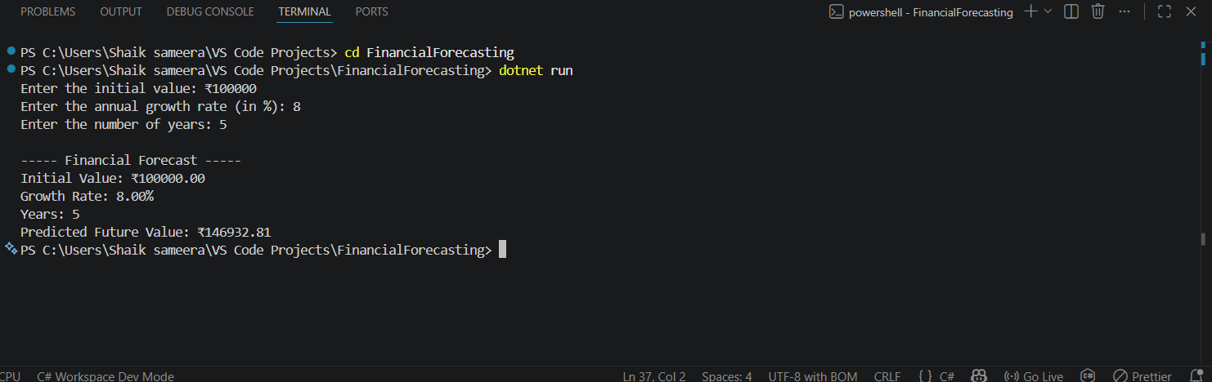

Time Complexity :
Each recursive call performs one multiplication and decreases years by 1.
Time Complexity: O(n)
where n is the number of years.
How to Optimize the Recursive Solution
The current solution makes one recursive call per year.
For very large values of n, recursion can:
• Use more memory
• Cause stack overflow errors
Use Iteration
An iterative solution uses constant memory.
Time Complexity: O(n)

Space Complexity: O(1)
Use the Mathematical Formula
The future value formula is:
Future Value = Initial Value × (1 + r)^n

